**LAB # 01**

**Tasks :**

**Download, install Android Studio on the system.**

**Verify SDK settings within the Android Studio**

**Creating shortcut of Studio.exe or Studio64.exe**

**Updating PATH environment variable for SDK\platform-tools**

**Stopping WSearch service**

**Excluding folders in Windows Defender antivirus.**

**Solution:**

**Download, install Android Studio on the system.**

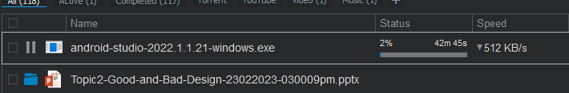

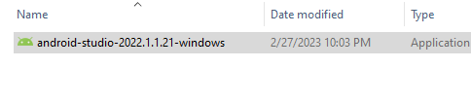

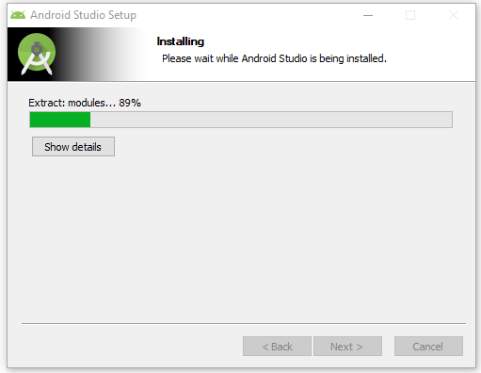 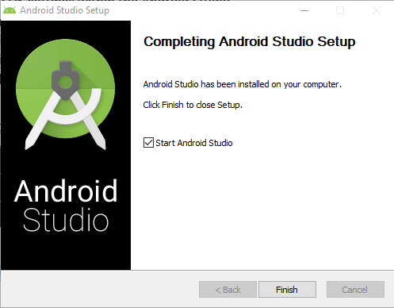

**Verify SDK settings within the Android Studio**

**Updating PATH environment variable for SDK\platform-tools**

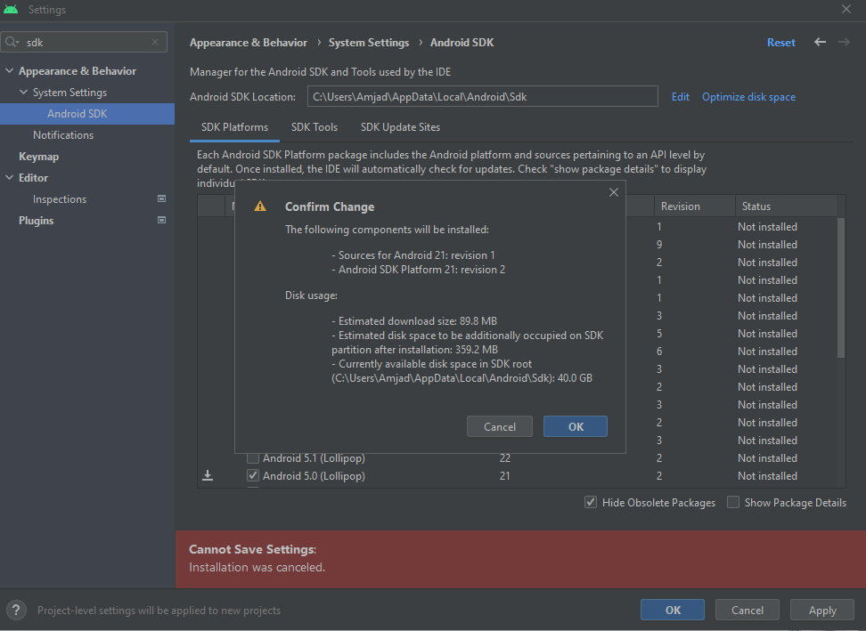 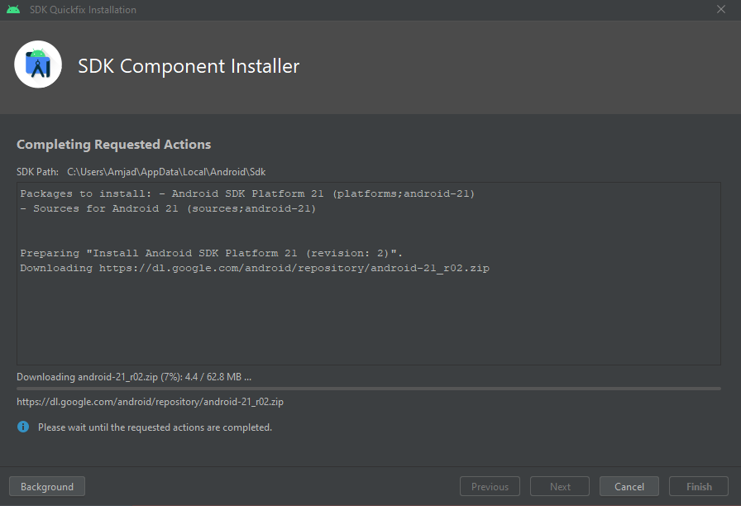

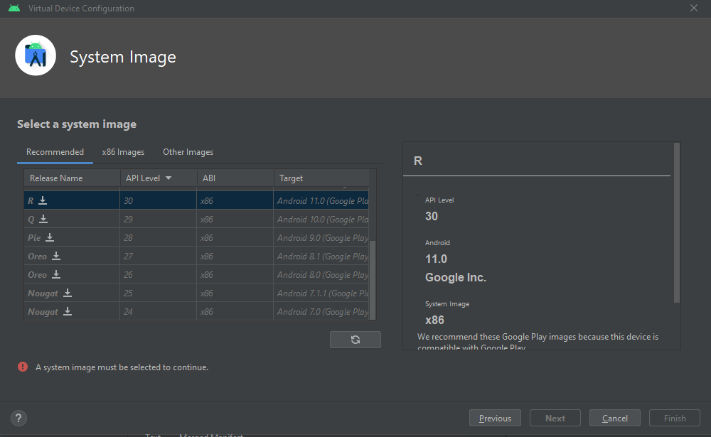

**First Program:**

|  |  |
| --- | --- |
|  |  |